Biodiesel Processing Using Supercritical Technology

Business Plan Summary
To build and operate multiple biodiesel plants nationwide and overseas

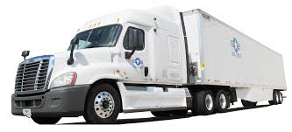
A Project By:
February 2018

Overview
Jatro Renewables (“the Company”) is planning to build a chain of biodiesel (BD) plants it will co-own and operate through a joint venture holding company. Actual plant production will range in output from 15 to 100 million gallons per year, and actual locations will depend on local market demand and the availability of feedstocks to produce the fuel.
Since 2004 and 18 biodiesel plants under its belt, Jatro’s core competencies have been designing, installing and operating biodiesel plants.
In November 2015, at a 60 million gallon per year (mmgy) ethanol plant in Illinois, the Company commercialized its first patented “Supercritical” biodiesel process (called Super).
This system is considered a technology achievement and break-through as it significantly lowers biodiesel production costs about 30% while allowing for a far wider choice of feedstock types, many costing half or less than those traditionally used.
In January 2017, the Company started design work integrating their patented Supercritical biodiesel plant at a 57mmgy ethanol plant in central California. Completion is expected by mid-summer 2018.
And later this year, the Company expects to begin construction of a 15mmgy plant in California.
What’s driving Super biodiesel
- Minimum 50% to 60% cleaner engine emissions
- #2 conventional diesel easily blends with up to 20% Super biodiesel and can be used anywhere #2 diesel is used, even in colder climates
- Super biodiesel has a higher cetane rating (47-55) compared to #2 diesel. This higher rating provides better engine performance including easier starting
- Super also adds lubricity to #2 diesel fuel even when blending 5% Super (reason: to reduce pollution, sulfur was removed from #2 diesel leaving the engine without proper lubrication)
- Super can process feedstock oils with up to 100% free fatty acids (FFA). 98% of Biodiesel plants are unable to process over 15% FFA and 52% can not process over 2% (i.e. those using soy oil)
- Manufacturers provide standard vehicle warranties when using up to a 20% biodiesel blend.
Plant Deployment Strategy
As indicated, the Company will be comprised of a holding company with Super biodiesel plant owners bringing their expertise and certain assets for each new project. However, to insure uniformity and the highest level of fuel quality for the long-term, the Company will oversee:
- System integration design, permits . . . leading to a completed commercial Super plant
- Remote 7/24 plant operations oversight to insure processing integrity and fuel quality
- Co-ordination for off-take agreements with petroleum distributors
- Develop, provide and manage feedstocks sources and logistics
- The Company will support a funding process for building additional plants.

Operations Overview
Regarding daily operations of plants. As noted, the Company will act as a sort of franchisor where the Company has real time, 24-hour oversight of each plants’ production process with ability to monitor the quality of fuel being produced using spectrometers to evaluate the liquids at any stage and remotely access the same screens as plant operators. This is designed to insure consistent fuel quality as well as monitor the actual performance of the equipment being used. It is also a back-up to insure the plant operators are operating reliably.
Technology Development
In three to four years, when cellulosic-type feedstocks are more available, plants will be adapted to use these feedstock sources. Also, plants will be located close to the feedstocks rather than within the served markets primarily, as the new feedstocks will be significantly more plentiful as trees and grasses etc. are ubiquitous. It is envisioned the Company would license, not internally develop, the process to convert cellulosic biomass into oils.
Production Overview The table below provides a summary comparison of capex and opex costs for Traditional Biodiesel vs Jatro Renewables’s Supercritical process
25mmgy Plant Criteria | Traditional  BIODIESEL | Supercritical  BIODIESEL
Production/Year (gals) | 25,000,000 | 25,000,000
CAPEX | $27,500,000 | $30,000,000
Cost Per Nameplate Gal. | $1.10 | $1.20
Feedstock/lb (dlvd) | $0.28 | 0.25  (using 22% low FFA feedstock)
Feedstock/gal | $2.10 | 1.89
Operations | $0.67 | 0.47
Total Cost | $2.77 | 2.36
Revenue B100 (dlvd.) | $3.35 | 3.35
By-Products (fob) | $0.04 | 0.09
Total Revenue/gal | $3.39 | 3.44
EBITDA/gal | $0.62 | 1.01
Total EBITDA/Year Avg. | $15,500,000 | 25,250,000
First Year EBITDA | $10,500,000 | $15,500,000
Months to Payback | 25 | 17
IRR (10 years) | 45% | 65%

Market Size and Growth
California currently offers the greatest market for Super biodiesel in the U.S. as they instituted the low carbon fuel standard (LCFS), a subsidy with a monetary incentive to produce the lowest low carbon fuel. This is in addition to the EPA’s Renewable Fuel Standard.
However, other states and cities are expected join the trend. For instance, New York City indicates plans to switch to using biodiesel in city vehicles and has already mandated a 5% biodiesel content in the State’s heating oil. Oregon and Washington states have also their versions of the LCFS. Minnesota and a number of other states plus Canada are considering similar policies.
Joint Venture Partnership
As noted, the Company will be comprised of several partners, each bringing their own expertise and contributions to create a chain of Super biodiesel plants on a joint venture basis with the actual plant operators who could be ethanol plant, biodiesel plant, diesel refinery and other owners(see diagram):

Jatro Renewables will take the lead role in the project including an internal R&D plan for BD plants which will eventually encompass adding a front end process to covert cellulosic biomass (woody biomass, forest slash, grasses etc.) into oils, and used in the existing BD plants.

Project Summary
- The Company plans to build and operate multiple plants, and strategically located as close to feedstocks and end-user markets as possible
- The Super technology has an advantage over its competitors by providing a particularly simple process that is less costly to operate, with scalable throughput from 15 to 100mmgy
- The Super process utilizes a unique patent, and is in full force for at least two more years
- Low cost production. The Super plant, versus other biodiesel technologies, will use less carbon intensive feedstocks; allow up to 100% free fatty acid feedstocks; and because no catalyst is ever used, the by-product glycerin is worth double the value of traditionally produced biodiesel
- When co-locating at an ethanol facility, plant and operating costs are largely mitigated by sharing existing assets (yet plant is designed to always operate autonomously when required)
- Market dynamics will dictate the volume of biodiesel produced
- Within 3 to 5 years, the Company plans to augment its existing plants with a front-end procedure to extract oils from woody biomass (forest slash, wood chips, used lumber etc.). It is envisioned this technology will be licensed from one of several promising technologies soon to be reaching the commercial stage
- Plants will need about 20 to 40 full-time personnel for production and back office. In the construction phase (15 months) approximately 80 personnel in various trades will be required
- Using conservative assumptions for a new 25MMgy plant, it will produce approximately 15m gallons in the first year (60% of full throughput); and with stabilization in the second and subsequent years 90% to 100% of nameplate consistently
- Production volumes translate to a first year total revenue of $51,600,000, and an EBITDA of about $15,500,000 (based $3.44/gal. delivered in California) with all subsidies passed through to distributor/blender. In the second and subsequent years those numbers will be ~ $86,000,000 in revenue with an EBITDA of $25,500,000, yielding an Internal Rate of Return (IRR) of ~65%
- A third party engineering company will be hired to verify that federal, state and local compliance requirements are met including leading to final registration approvals during plant start-up through being confirmed as operating “commercially”
- The Company will also hire an engineering firm to act as the project’s engineering, procurement and construction company (“EPC”). Their contract will include a guarantee of meeting plant production quantities and qualities; including liquidated damages for Jatro JV if the schedule is not met or production volumes not realized
- While the Company principals and management are seasoned chemical conversion technology, engineering, development, finance and operating experts with proven experience (e.g.
Jatro Renewables has built or engineered 19 biodiesel plants), the Company also includes experts in drafting insurance wraps to mitigate all risks for the entire project. These coverages include start-up, technology, feedstock supply, construction and off-take sales contract risks.
APPENDIX A
Properties | Traditional Biodiesel (FAME) | Supercritical Biodiesel (Super™)  ASTM 6751
GHG Emissions | 50% below baseline¹ | 60% below baseline¹
CAPEX / OPEX | $1.10 | $0.67 | $1.20 | $0.47
Transportation | Truck, rail or barge | Truck, rail or barge
Storage | All tanks, above ground | All tanks, above ground
Engine Compatibility | < 20% BD to meet warranties | < 20% BD to meet manuf. warranty
Cetane | About 47 to 51 | About 47 to 55
Cloud Point | Depending on feedstock blend  -2°C to +8°C | Depending on feedstock blend  -5°C to +8°C
Distribution | Max blend to <80% biodiesel, typically to 2% to 20% | Must be blended to <80% biodiesel, typically 2% to 20%
Fuel Color | Light yellow/ or light red | Clear (like water)
Retail Infrastructure | Separate pumps, tanks if 100% | Separate pumps, tanks if 100%
Table I. Features Comparison (Traditional Biodiesel vs. Super)
Properties | Petrodiesel  #2 Diesel | Biodiesel (Super™)
Cetane | 40-50 | 47-55
Energy Density, MJ/kg | 43 | 38
Density, g/ml | 0.83-0.85 | 0.88
Energy Content, BTU/gal | 129k | 118k
Sulfur | <10 ppm | <5 ppm
NOx Emission | Baseline | +10
Cloud Point, °C | -5 | -2 to +5
Oxidative Stability | Baseline | Fair
Cold Flow Properties | Baseline | Good
Lubricity | Baseline | Excellent
Particulates | Baseline | 33% lower
CO¹ | Baseline | 20% lower
Hydrocarbons¹ | Baseline | 27% lower
Table II. Fuel Properties Comparison
APPENDIX B
Historically, when a subsidy is lost, feedstock is adjusted downward by suppliers to meet #2 Diesel fuel parity. The most predominant case was the loss of the $1.01/gal. blenders’ credit five times in 10 years.
APPENDIX C
Plant Gallery
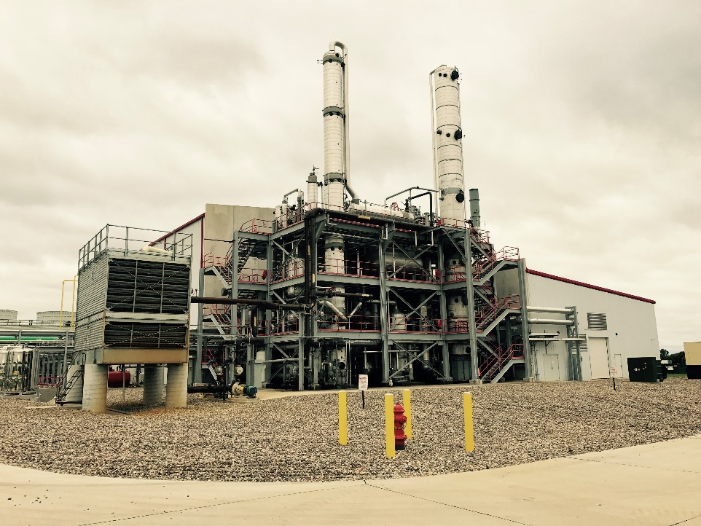
CHS, Inc. Super Biodiesel plant co-located with 110mmgy Ethanol plant, Annawan, IL
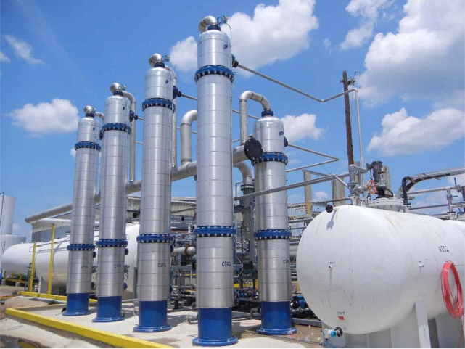
Vanguard Biodiesel 15mmgy, Pollock, LA

APPENDIX D
Plant Projects to Date Gallery
- American Ag Fuels, Defiance, OH
- Middletown Biofuels, Harrisburg, PA
- Michigan Biodiesel, Bangor, MI
- Walsh Biofuels, Mauston, WI
- Mt. Coco Products, Philippines
- Imperial Valley Biodiesel, El Centro, CA
- Greenlight Biofuels, Princess Anne, MD
- Western Biodiesel, High Plains, AB, Canada
- African Energy Initiative, Kampala, Uganda
- Jatrodiesel, Miamisburg, OH
- Center Alternatives, Cleveland, OH
- Vanguard Synfuels, Alexandria, LA
- Biovantage fuels, Belvidere, IL
- Washakie Renewables, UT
- Greenleaf Biofuels, New Haven, CT
- United Refining, Warren, PA (engg only)
- Mid America Biofuels, North Platte, NE
- Patriot Ethanol, Annawan, IL
- Calgren Energy, Pixley, CA
- BioCalifornia, Los Angeles, CA (proposed, May 2018)

