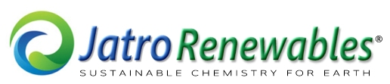
EXECUTIVE SUMMARY
JatroCBD.com
a Division of Jatro Renewables, Inc.

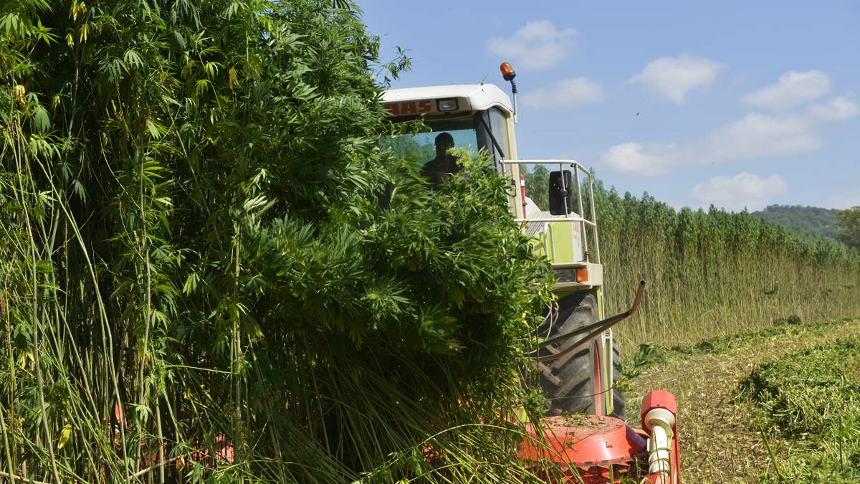
(Above, hemp harvesting in Ontario, Canada. The weed takes 8 to 12 weeks to harvest from germination and from 2 to 4 crops per year depending on latitude and altitude).

January 21, 2019
BUSINESS OVERVIEW
Introduction
Through a wholly owned subsidiary Jatro CBD, Jatro Renewables is capitalizing on new rules in the 2018 Farm Bill that allows the nationwide cultivation, processing and distribution across state lines of industrial hemp (providing total tetrahydrocannabinol (THC) is less than 0.3%).
Jatro has already created a working bench-top oil extraction from hemp capability and has produced several Certificates of Analysis revealing the technology will effectively extract oil in quantities and quality equaling or exceeding current industry benchmarks (see Appendix D).
The Farm Bill provides nationwide rules, long overdue, that opens up a significant opportunity for a once dormant hemp industry. What follows from farms will be a myriad of hemp products made from its oils and fibers: medicines, textiles, biodegradable plastics, construction materials, health food, ethanol, biodiesel and much more (see Appendix 4).
And as more states legalize hemp cultivating and processing rules, and as scientific research becomes more widely accepted and more regulated by governments, sales are expected to eclipse $2 billion/year by 2020. (By comparison, the global industrial hemp market size is estimated at $4.4 billion for 2018 and is forecast to expand at a CAGR of 14.0% over the next three years).
Many hemp-based products have been manufactured outside the U.S. for decades, and where it has always been legal, so a track-record to emulate is possible which should provide much insight into the marketing parameters adopted here in the U.S. and Canada.
Therefore, with Jatro’s 15-year background in converting oils into biodiesel and from biomass, the Company is confident it has the technical expertise to offer significant value in engineering and system operations for this massive, emerging industry.
Funding/Use of Proceeds
Jatro is seeking a partner to come in for approximately $750k in stages which will be used for plant product development, equipment, inventory and working capital.
The company is now transforming a modified scaled-up version of its bench-top design to become a fully operational unit capable by extracting between 7 to 10 lbs (4,450 grams) per day from 100 lbs of hemp.
However, while this initial unit will use an industry standard ethanol and CO₂ process, it will only be for in-house use and temporarily. That once the market for larger throughput begins (about >1,000 lbs/day), the company will offer its own original process that is easier to manage and with a 25% to 30% lower cost in chemicals when compared to other units currently emerging in the industry.
Industry Background
The new Farm Bill law has overnight boosted the hemp industry almost like magic! However, producers and processors are already realizing a fast-growing demand for high quality THC and CBD oils (including full spectrum, isolate, distillate and crystalline iterations).
Essentially existing commercial hemp oil extraction processing wasn’t ready for the market. For instance, typically processing was done in batches, a method which involves manually loading and unloading and with logistical limitations of approximately 1,000 lbs of raw hemp per day.
Scaling up production meant adding equipment and personnel on a one-for-one basis in order to increase processing volumes. That was not sustainable.
Current Activities
It was these issues that became the catalyst to prompt Jatro to address the CBD market.
After several months of trial and error the Company came up with a design and built a working oil extraction demonstration model ̶ a bench-top sized apparatus that eventually produced very small quantities of the highest quality CBD oil (and confirmed from tests by a 3rd party certified lab).
The achievement was due to the extraction medium chosen and is a very efficient method of biomass extraction. This method greatly enhances the overall operations process including the ability to run automatically and continuously. Also, the system uses organic chemicals at a far lower cost than is traditionally used – and without compromising the quality of oil produced.
Hence, a need has been developed for scaled-up large industrial processing capacities with efficient, continuous feed extraction and post-processing capabilities. Jatro CBD is ready to meet the challenge!

About Jatro Renewables
Founded in 2004, Jatro Renewables Inc. (JRI) is a biodiesel engineering company focused on developing and commercializing novel biodiesel manufacturing processes including its patented Supercritical processing platform. It’s manufacturing facilities are in Miamisburg, OH.
The Company has designed and built 19 biodiesel plants and operated their own facility for 3 years. It’s claim to fame has been the introduction of a “supercritical” plant design which reduces chemical usage by 25%, labor by about 20% and allows the processing of feedstocks high in free fatty acids at about half the typical feedstock cost (see details Appendix 7).
To summarize: With the temporary turn-down in the renewable fuels industry, JRI has adjusted its business strategy is leveraging its core competencies to take advantagve of a newly minted hemp industry and develop a unique methods and processes of extracting oils from biomass.
About The Hemp Industry
There is no doubt that CBD is the new buzzword. From the medicinal laboratories of the largest Canadian producers to the juice bars on Rodeo Drive, everyone is talking CBD.
As more U.S. states legalize medical marijuana and hemp processing rules, and as scientific research becomes more widely accepted and more regulated by governments, CBD product sales alone are expected to eclipse $3 billion by 2020.
The hemp industry grew 14% in 2017 amidst continued domestic legal and regulatory challenges. The industry was bolstered by explosive growth in the hemp-derived cannabidiol (CBD) category that grew from a market category that did not exist five years ago to $190M in sales in 2017.
For 2018 the industry will reach close to a $1.0B market led by hemp-derived CBD, food, personal care, and the beginning of large scale industrial products such as in fuels and chemicals.
As legal and regulatory barriers are removed (as we are witnessing with the new 2018 Farm Bill) and consumer education spreads, it is estimated the U.S. hemp industry will grow to a $2.2B market by 2022 with an estimated 5-year compound annual growth rate of 14.4% (2018-2022).
Signed just a few weeks ago, the Bill allows farmers to cultivate, process, distribute and sell CBD oil ̶ providing the plant’s psychoactive compound THC (tetrahydrocannabinol) is less than 0.3% (which provides no so-called “high”).
On market size, only about 8% of U.S. population use marijuana, whereas 92% can partake in the benefits of CBD, now that it’s legal. That’s about 300 million humans. And since CBD is very good for pets, add another potential 164 million users!
FUNDING/USE OF PROCEEDS
JatroCBD is seeking investors to join the Company in its pursuit of its new CBE oil extraction market. And because the market is so very early stage, the cost of entry is still quite low. But this is sure to change as the industry quickly matures.
The total funding amount sought is $750,000. Proceeds will be used to: (i) directly continue development of JRI’s biomass oil extraction process; (ii) peripheral equipment for product packing and management; (iii) hemp feedstock for oil extraction; (iv) inventory and working capital.

KEY INVESTMENT CONSIDERATIONS
Unique Business Strategy
Because the Company’s process is designed for higher volume CBD Producers, who are rushing into action and just beginning to evaluate their markets and equipment they’ll need, the Company has a window to work within, concurrent with its technology development.
This ancillary effort will be in stages: (i) immediately begin selling CBD items on the internet using oil from another vendor but with JatroCBD label on all SKUs, with all items shipped by vendor to customers; (ii) at about the 3rd or 4th month we begin selling oil produced by the Company’s own equipment including all packaging and shipping; (iii) after the 9th month offer wholesale CBD oil to retailers on a private label or on our label basis; (iv) offer complete plant solutions to all takers.
Concurrently, the Company will be establishing forward (hedged) purchases of hemp from farmers as a means of supporting its own retail effort, but also for its larger/Producer customers who are using the Company’s equipment.
The Company’s first plant line will be made available in five volume (nameplate) sizes. The volume of hemp in pounds input and finished oil in (grams per day): (i) 1000 lbs (30k g); (ii) 500 lbs (80k g); (iii) 5000 lbs (160k g); (iv) 7500 lbs (240k g); (v) 10000 lbs (320k g).
To management’s knowledge, the number of vendors offering hemp oil extraction systems for CBD consists of a about 15 companies in the U.S. (see list Appendix C), and an undetermined number in China. All, except one company, has a process as efficient as the Company’s. The chief differentiator is attributable to the chemical used to extract the oil.
The Company’s proprietary chemical formula significantly reduces the chemical cost compared to other systems by decreasing the dwell time of oil being treated through the various process stages. This also lowers the labor cost as throughput is faster so less personnel are required to operate the plant.
However, the downside currently, is that plants we envision building are far larger than the current market is using because volumes of CBD oil are still low and developing. So, CBD Producers are using smaller systems than the Company’s technology is not suited for. This will change very soon, within a year or less, the way developments appear to be ramping up.
BENEFITS OF CBD
There is plenty of anecdotal evidence supporting CBD’s healing benefits ̶ and for a large number of ailments and mostly collected from medical marijuana users across the country and in Europe (see Appendix B). In fact, the first CBD use as a certified medicine was approved in June 2018 by the FDA (Federal Drug Administration) for significantly reducing epilepsy convulsions. CBD products have a massive market potential with an embryonic industry now on the cusp of becoming mainstream. CBD will lead that.
Essentially as an agricultural commodity, hemp is cultivated for use in the production of a wide range of products, including biodiesel and ethanol, chemicals, foods and beverages, cosmetics and personal care products, nutritional supplements, fabrics and textiles, yarns and spun fibers, paper, construction and insulation materials, and other manufactured goods.
But there will be entire other industries emerging using oils and the hemp plant’s fibers for renewable fuels, chemicals, textiles, plastics and more.
JatroCBD will concentrate on the extraction, manufacturing and processing of hemp for its high concentrations of CBD oils with less than 0.3% THC.
A Brief Overview of Hemp Oil
The recently signed 2018 Farm Bill changes rules on the cultivation, distribution and use of hemp but with growing restrictions that limit the level of THC (tetrahydrocannabinol) to less than 0.3%. THC is the psychoactive compound in hemp.
Hemp can be grown as a fiber or seed. Botanically, industrial hemp and marijuana are from the same species of plant, the cannabis sativa, but from different varieties or cultivars that have been bred for different uses.
For instance, hemp can be grown to have high levels of cannabidiol, more commonly called CBD, for its medicinal compounds; the same plant can be cultivated to produce lower levels of CBD and from small to very high levels of THC.
To differentiate the two strains, the CBD-rich plant is called hemp or cannabis, the THC-rich, marijuana. The cannabis sativa plant also contains other cannabinoids, 113 in total, and these together with THC and CBD plus terpenes and flavonoids make up the entire plant.
From the cultivation perspective, hemp is one of the fastest growing biomasses in the world and requires little to no pesticides, no herbicide controls, no erosion of the topsoil while producing oxygen and it actually cleans the soil by absorbing its contaminants.
Cultivators, producers, distributors and retailers of hemp must register as per local state laws and it can be grown anywhere in the United States including being shipped across state lines for whatever purpose is required.
Hemp is considered the same as any other crop by the USDA (U.S. Dept. of Agriculture) when it comes to financing, hedging and insuring.
In states where rules allow medicinal and recreational use of marijuana there is no ceiling on the amount of THC in hemp or marijuana products, but state laws must be followed to the letter.
Both THC and CBD have excellent medicinal properties when taken together or separately (and where legal).

*

Non-intoxication and non-psychedelic at the 0.3% THC level
Hemp Business Journal
Grand View Research, Inc. 201 Spear Street 1100, San Francisco, CA 94105, United States. Phone: +1-415-349-0058 or 1-888-202-9519
Various embodiments the oil is processed into
SC Labs, Santa Cruz, California
Almost 100% of producers use a hydrocarbon and CO2 extraction process. Only one company is known to use a process remotely similar to Jatro’s.
Jatro is currently considering applying for a patent or possibly trade secret
Hemp Business Journal
Hemp Business Journal
GW Pharmaceuticals, Plc (London) is a global leader in developing cannabinoid-based medicines. GWpharm.com

